ADOBE PREMIERE PRO FOR COMPLETE BEGINNERS
by Navin Kulshreshtha, Lead Instructor at LearnPremiere.com

WEEK 6 SUMMARY

Adding Text
- In the Timeline, move your Playhead to the point where you would like to add some text.
- Choose the Type tool from the Tools panel.
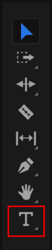
- Single-click anywhere inside the Program Monitor and start typing. The text will appear on-screen. For now, it will be the default size and color.

Moving Text
- Choose the Selection tool from the Tools panel. It is the tool at the very top.
- Then click and drag the text in the Program Monitor wherever you want.
- A Lower Third is text that appears in the lower part of the screen and provides useful information such as the name of a person or location.

Safe Margins
- This is a visual overlay that will help you place your text.
- Right-click inside the Program Monitor and choose Safe Margins to turn them on.
- Now two boxes will appear on-screen. The basic idea is that your text should be inside the boxes.
- If the text gets too close to the edge of the screen it might get cropped on some people's screens.
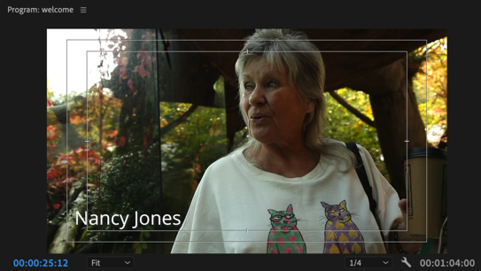

Essential Graphics Panel
- You will most likely want to modify the text properties such as font, size and color. We will use the Essential Graphics panel for this.
- Switch to the Graphics workspace by choosing Window > Workspaces > Graphics from the top menu.
- The Essential Graphics panel should appear on the right of your screen. If not, then choose Window > Essential Graphics from the top menu and it will appear.

Modifying Text
- Be sure the text clip is selected in the Timeline.
- At the top of the Essential Graphics panel click on the Edit tab
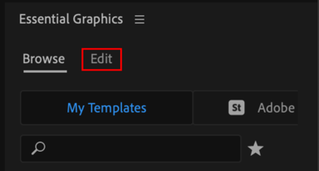
- This will bring up the text properties. Scroll down to see all the basic properties such as font, size, weight and several advanced ones too:
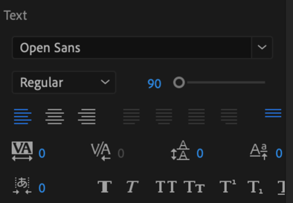
- If you want to change the color, then modify the Fill color.
- NOTE: If the Essential Graphics panel is blank then be sure to select the text clip inside the Timeline. And if necessary click on the text layer at the top of the Essential Graphics panel:
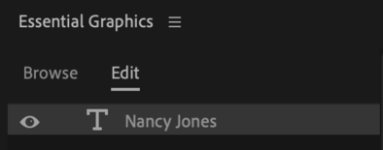

Duplicating Text
- If you want to use the same text elsewhere in the Timeline, simply Opt-Drag (Mac) or Alt-Drag (Windows) the text clip and it will be duplicated.
- This is very useful if you are planning to use the same styled text throughout the Timeline.

Adding Graphics
- At the end of the video we are going to create a layered graphic that includes 3 layers: a colored background, logo and text.
- You can layer clips one on top of the other inside the Timeline to do this.

Color Matte
- This will be the colored background. Choose File > New > Color Matte from the top menu.
- For the Video Settings simply click on Ok.
- Then choose any color you want or enter a color code if you have one.
- Choose a name for the matte, or just accept the default name, Color Matte.
- The Color Matte will now appear in the Project panel. Drag it into the Timeline.

Adding Logo
- From the Project panel, simply drag the logo into the Timeline immediately above the colored background (on Track 2):
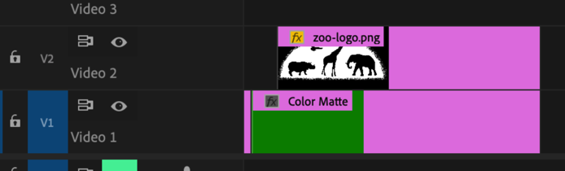
- If necessary you may have to import your logo first.
- For the best results, the logo should be on a transparent background. PNG files support transparency but JPG files do not.

Adding Text
- As we did previously, select the Type tool and single-click in the Program Monitor and start typing. Then modify its properties in the Essential Graphics panel.
- Another text clip will appear inside the Timeline.
- To add another text layer, click on the New Layer button near the top of the Essential Graphics panel and choose Text.
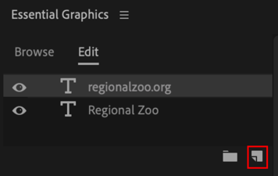
- Now another text layer will appear that you can move and modify.

Transitions
- Now you should have 3 clips layered on top of each other in the Timeline.
- Modify their durations, positions and add transitions to make it look more professional. You can be creative here.
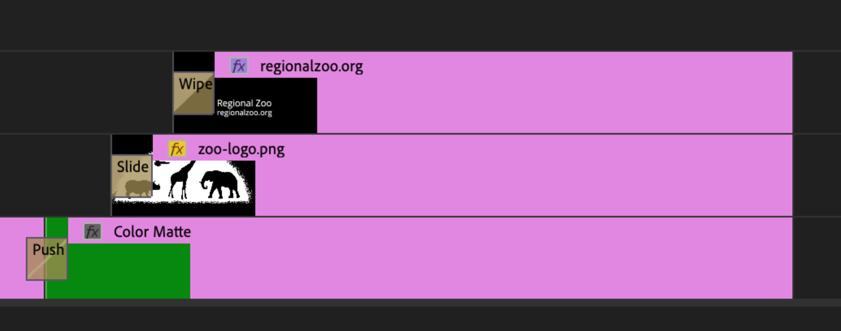

Replace Edit
- Currently we have a Color Matte inside the Timeline. What if we wanted to replace it with another clip?
- The slow way is to delete the Color Matte and then add another clip, but then you will have adjust the timing of the new clip and re-do all the transitions.
- Far quicker is a Replace Edit.
- In the project panel, locate another clip and then Opt-Drag (Mac) or Alt-Drag (Windows) the clip over top of the Color Matte in the Timeline.
- Release your mouse button and then release the Opt or Alt key. Now the color matte will be replaced with the new clip, and keep all the transitions!

Fade Out Music
- The fastest way to do this is with a transition.
- Right-click the edge of the music clip and choose Apply Default Transitions. Now a crossfade transition will appear on the clip.
- Double click the transition and change the duration to 00:00:02:00, which is 2 seconds. Make it longer or shorter if you want.
- Often a longer transition like 3 seconds will sound more smooth and professional.

Export
- To export a video, click anywhere inside the Timeline and choose File > Export > Media from the top menu. Then choose these settings:
- From the Format menu choose H.264, which is a popular form of compression.
- From the Preset menu choose Match Source - Adaptive High Bitrate
- Click on the Output Name and browse to the 03-Final-Exports folder inside the project folder, or the location of your choice. Give the file a descriptive name.
- After exporting you will end up with an MP4 file on your computer that you can share with the world!

Congratulations!

- You are well on your way to doing amazing things with Premiere Pro.
- Gather some of your own footage and practice the skills you've learned here. Don't wait! Remember: "Use it or Lose it."
- I'm looking forward to seeing your creations. Stay in touch! I would be happy to hear from you

 | All the best,  Navin Kulshreshtha  Lead Instructor at Learn Premiere

