ADOBE PREMIERE PRO FOR COMPLETE BEGINNERS
by Navin Kulshreshtha, Lead Instructor at LearnPremiere.com

WEEK 5 SUMMARY

EFFECTS

Effects are powerful ways to add a professional touch to your video clips. There are over one hundred effects in Premiere Pro! And hundreds more available from third-party developers.

Effects Panel
- The effects are located in the Effects panel.
- From the top menu choose Window > Effects to make this panel visible.
- In the Effects panel open the Video Effects folder to see all of the effects.

Warp Stabilizer
- Instantly fix shaky footage!
- Inside the Effects panel go into the Video Effects > Distort folder and locate the Warp Stabilizer effect.
- You can also type in the word "warp" into the search box at the top of the Effects panel to locate it.
- To apply an effect onto a clip simply drag it from the Effects panel directly onto a clip in the Timeline.
- Wait a few seconds and the clip will automatically stabilize.

Blur
- Inside the Effects panel go into the Video Effects > Blur & Sharpen folder and locate the Gaussian Blur effect.
- You can also type in the word "blur" into the search box at the top of the Effects panel to see all of the blur effects.
- Drag the Gaussian Blur effect onto a clip in the Timeline.
- Then in the Effect Controls panel (which is a completely different panel), next to Gaussian Blur, increase the Blurriness amount until the clip is blurry enough.
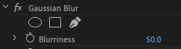
Mask
- By default the effect will apply to the entire clip.
- But what if you just want to apply the effect to a specific portion of the image? Such as just blurring someone's face? You can create a Mask.
- In the Effect Controls panel, immediately under the effect you will see 3 options for masking: Ellipse, Rectangle and Free Draw:
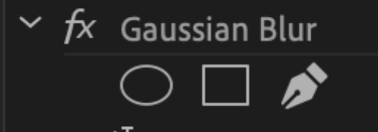
- Click on the mask of your choice and you will see it in the Program Monitor.
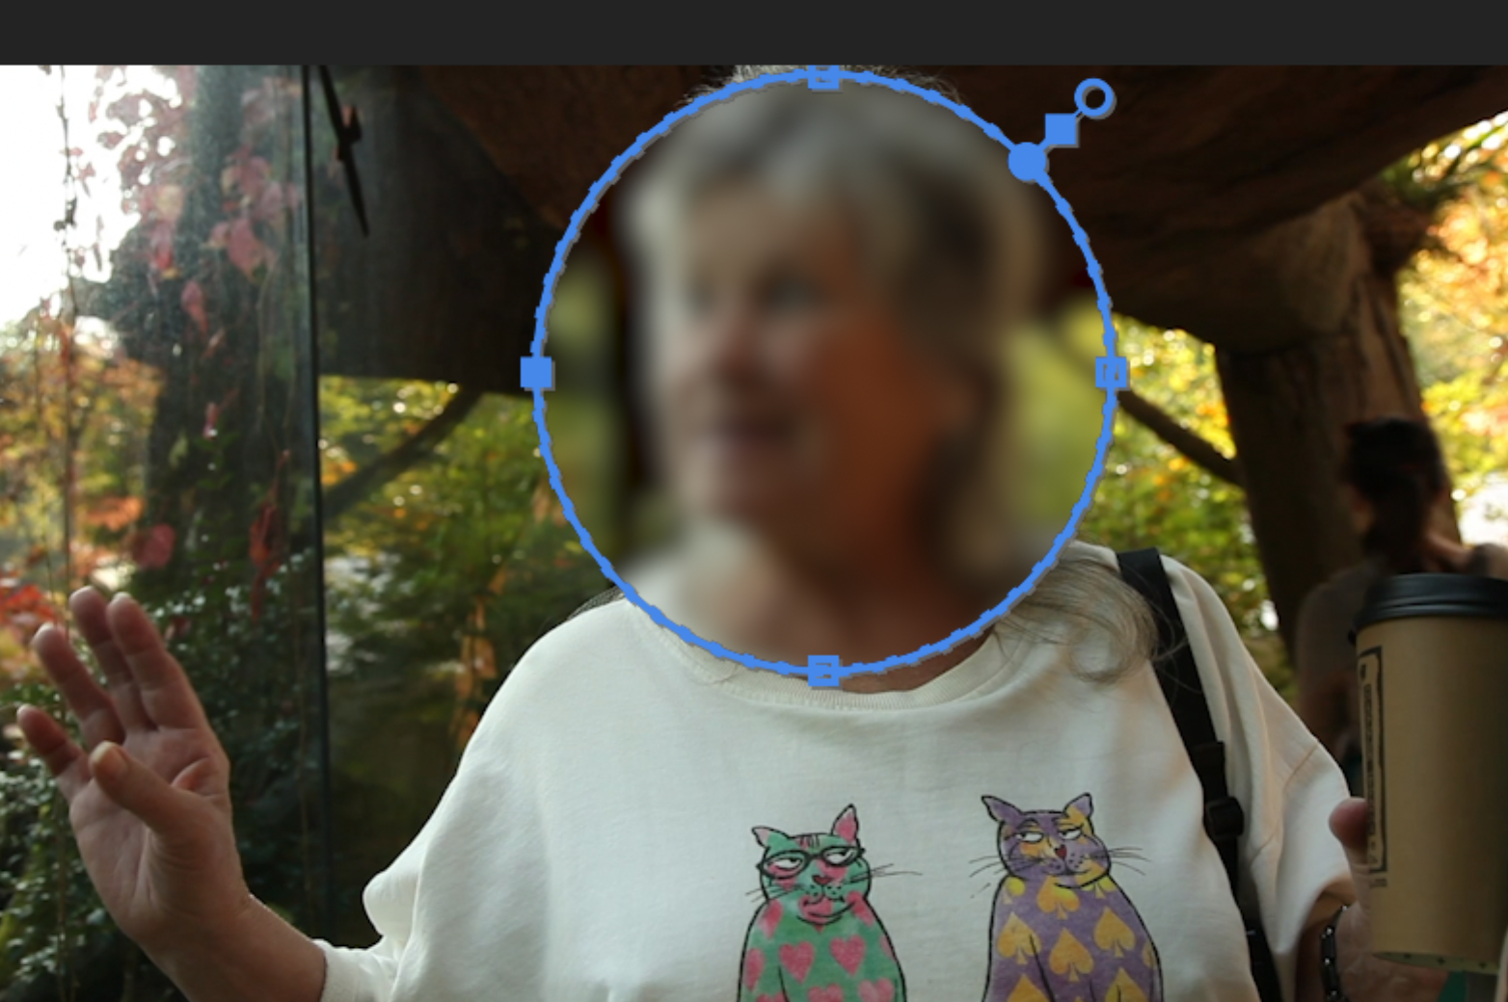
- From here, you can adjust the size of the mask by dragging the blue handles.
- Move it by dragging it around.
- In the Effect Controls panel you can also soften the edges by changing the Mask Feather amount.
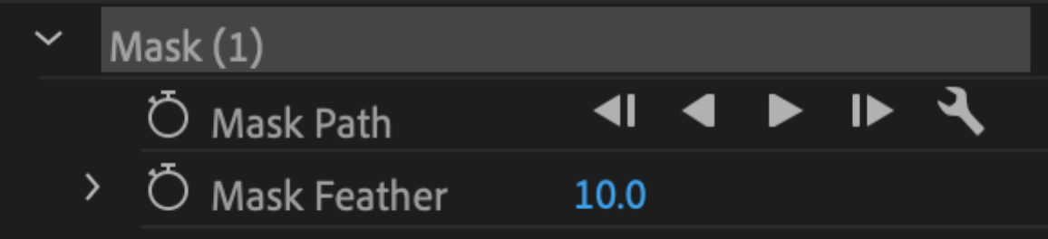
COLOR GRADING & CORRECTION

Lumetri Color
- Lumetri Color is such an important effect, that it has its own panel!
- Activate this by choosing Window > Lumetri Color from the top menu.
- You can also switch to the color workspace by choosing Window > Workspaces > Color from the top menu. Or choosing Color from the Workspaces panel (near top of screen):
Basic Correction
- Select a clip in the Timeline.
- Then in the Lumetri Color panel, click on the Basic Correction tab to see all the values there:
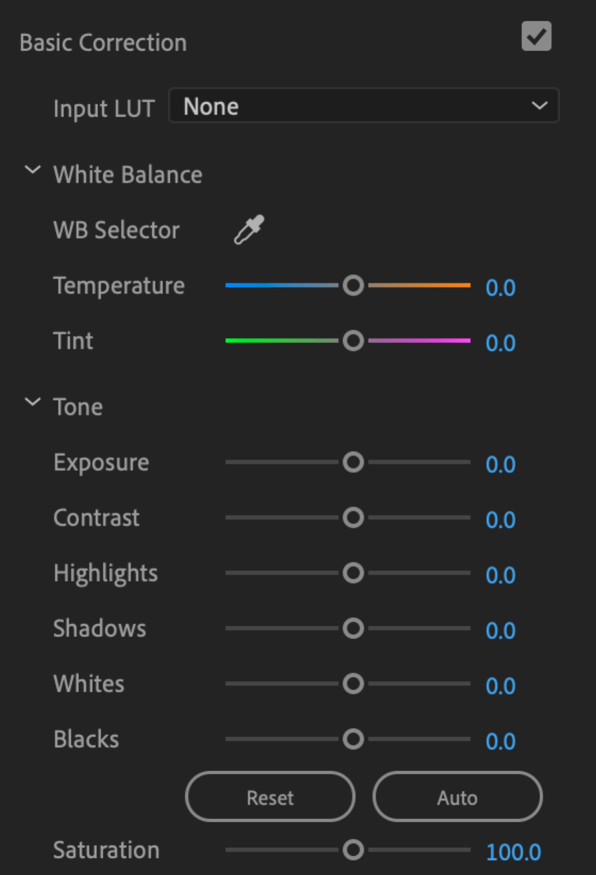
- White Balance, adjusts the color balance from blue to orange.
- Tint, adjusts the color balance from green to magenta.
- Exposure is like Brightness.
- Contrast, brights become brighter, darks become darker.
- Highlights, adjusts the brightest portions of image.
- Shadows, adjusts the darkest portions of image.
- Saturation, adjusts intensity of the colors.
- Using this panel properly will take some practice.

BONUS

Lumetri Scopes
- How bright is too bright? How dark is too dark? A scope will tell you when your image is becoming overexposed or underexposed.
- We are going to use the Waveform scope.
- Open the Lumetri Scopes panel by choosing Window > Lumetri Scopes from the top menu.
- Several scopes may appear. We are going to focus on the Waveform scope.
- At the bottom of the Lumetri Scopes panel, click on the Wrench icon and uncheck all of the scopes except the Waveform.
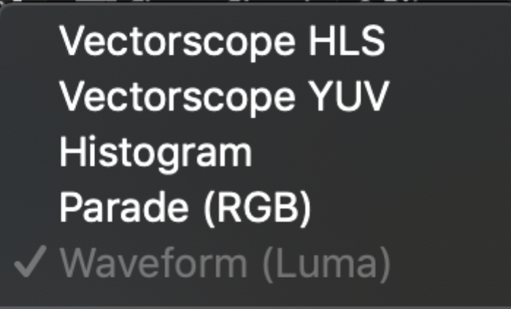
- Click on the Wrench icon again and choose Waveform Type > Luma.
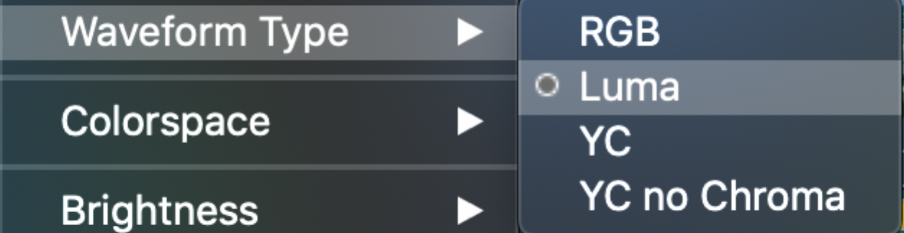
- This scope shows the (brightness) of the image. The left axis goes from 0 to 100.
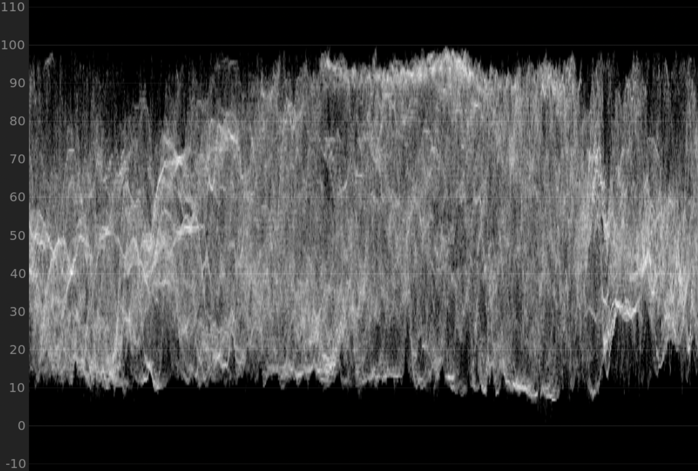
- If any part of the graph goes above 100 the image is overexposed.
- If any part of the graph goes below 0 the image is underexposed.
- Now you have some objective information to guide you during color grading.

