ADOBE PREMIERE PRO FOR COMPLETE BEGINNERS
by Navin Kulshreshtha, Lead Instructor at LearnPremiere.com

WEEK 4 SUMMARY

AUDIO

Audio Meters  - Pay close attention to the Audio Meters next to the Timeline.  - Volume is measured in decibels (db).  - A simple rule to keep in mind is that the volume can get close to 0, but never go above 0.  - Clipping occurs when the volume goes above 0, and the lights at the top of the Audio Meters will flash red. | 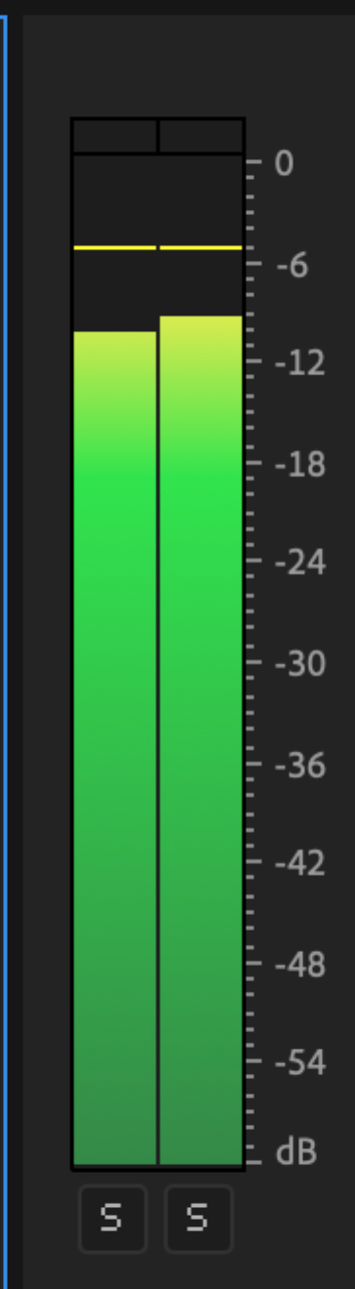
Rename Tracks
- It is a best practice to assign a purpose to each audio track and to give it a meaningful name.
- To rename a track, simply right-click on its name (such as Audio 1) and choose a different name.
- If you can't see the track name, expand the track height until you can see it. You can do this by double clicking the empty space in the track header.
- We named our tracks as follows:
  - Nat Sound
  - Dialogue
  - Music
- Other common track names: Ambient, Interviews, SFX.

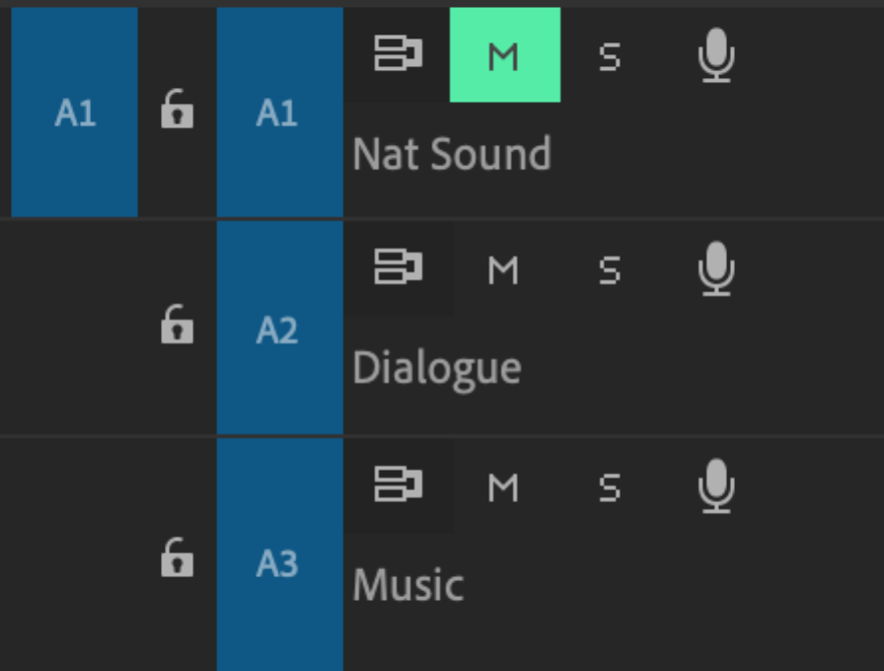

Volume of a Clip
- To adjust the volume of a single clip locate the horizontal white line and drag it up or down.
- Dragging up increases the volume; dragging down decreases it.
- To mute the clip, drag the white line all the way down to the very bottom until it can go no further.

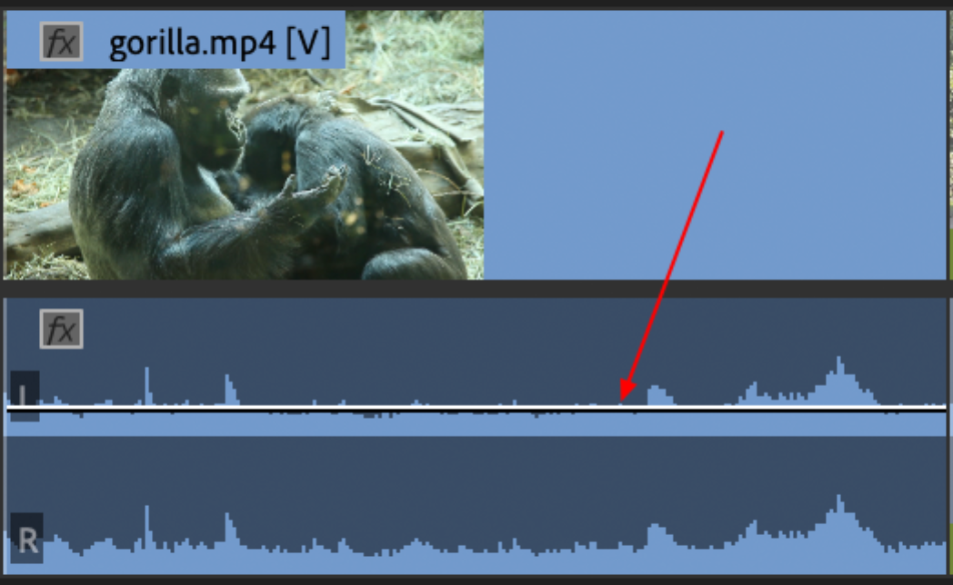

Mute Track
- To mute a track, simply click on the M button at the beginning of the track.
- In some cases you may want to mute the entire Nat Sound track if it is random or distracting.
- This will automatically mute all of the clips inside the track, which can save a lot of time.

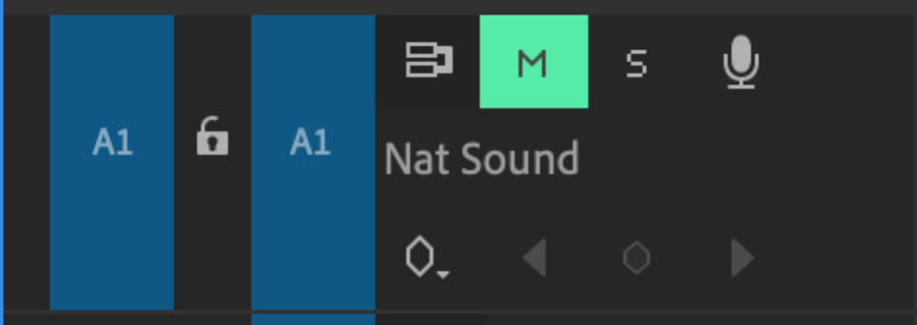

Adjusting Gain
- Gain is another way to adjust the volume of a clip.
- Right-click a clip in the Timeline and choose Audio Gain.
- Choose Adjust Gain and enter a value such as 3. This will increase gain by 3db.
- You can also put in a negative number such as -3 or -6 to decrease the gain.
- As always, pay close attention to the audio meters to make sure you never clip the audio.

Normalizing Audio
- Normalizing is one of the most efficient ways to set the volume of a clip.
- Right-click on and audio clip and choose Audio Gain as we did before.
- Select Normalize Max Peak and change the value to anything below 0 such as -3.
- The entire audio waveform will be modified so that it peaks at the value you specified (such as -3db). This is a great time saver!
- Do not choose a value above 0 in this case or else the audio will clip.

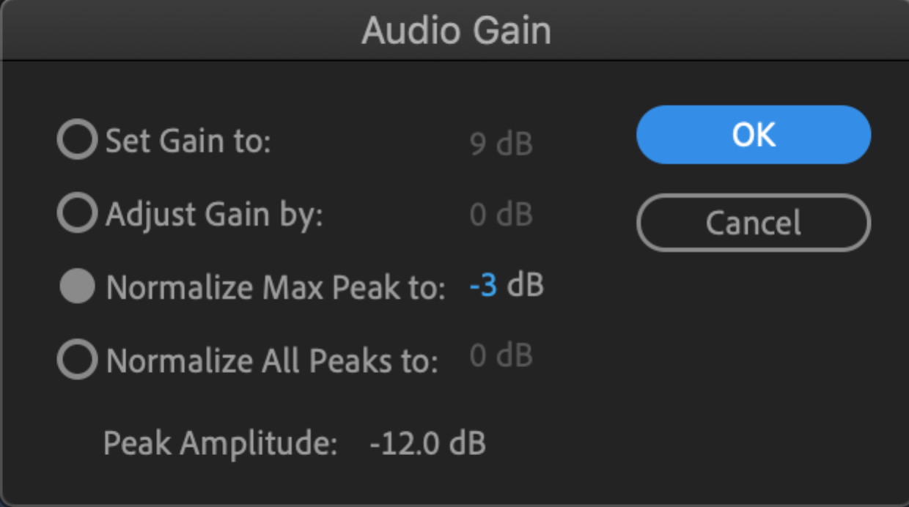

Keyframes
- A keyframe allows you to change the value of something over time. In this case, you will change the volume of the music over time.
- At times, you want the music to be loud. At other times, you want it to be quiet. Keyframes allow you to do this.

Pen Tool
- Select the Pen Tool from the Tools panel. This tool creates keyframes in the Timeline.
- Then click directly on the white line in the music clip to add a keyframe.
- Drag the keyframe down or up to change the volume.
- Keep adding keyframes and adjusting them until you have the desired effect. Here is an example with 4 keyframes. The volume goes down, then later on comes back up.

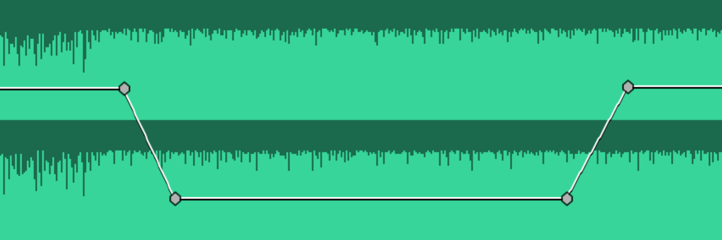

TRANSITIONS

Default Transition
- In the Timeline, right-click an edit point and choose Apply Default Transition. The default transition is the Cross Dissolve.

Transition Duration
- To change a transition's duration, double-click it and enter a value.
- The last number represents the number of frames, so 00:00:00:15 means 15 frames.
- If your footage was shot at 30 frames per second, then half a second would be 15 frames (00:00:00:15).
- If your footage was shot at 24 frames per second, then half a second would be 12 frames (00:00:00:12).

Other Transitions
- Premiere Pro comes with many transitions that you can choose from.
- All of the transitions are in the Effects panel, which can be activated by choosing Window > Effects from the top menu.
- Open the Video Transitions folder and the Dissolve folder to see two common transitions: the Cross Dissolve and the Dip to Black.
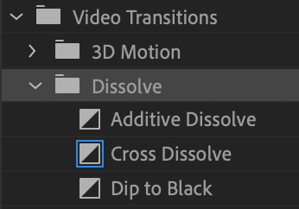
- Open the other folders to see the other transitions.
- To add a transition, drag and drop it into the Timeline in between two clips.

TRANSITION WORKFLOW

Manually dragging transitions and changing their duration is laborious. Here are some handy techniques to speed up your workflow:

Transition Duration
- Default transition duration is 1 second, which is often too long.
- To modify this, from the top menu choose Premiere Pro > Preferences (Mac) or Edit > Preferences (Windows) and then choose Timeline.
- Change the Video Transition Default Duration to another value.
- You can change the measurement to either Frames or Seconds. In this example, the duration is set to 0.5 5econds:

- You could set it to 0.25 seconds, 15 frames, 10 frames or whatever you want.

Apply Transitions Across Many Clips
- Select multiple clips in the Timeline. You can do this by Shift-clicking with your mouse or dragging across several clips with your mouse.
- From the top menu choose Sequence > Apply Video Transition. Keyboard shortcut for this is Cmd-D (Mac) or Ctrl-D (Windows).
- Now the default transition will be applied across all of the selected clips.

Change Default Transition
- The default transition is the Cross Dissolve, but you can change this.
- Go to the Effects panel and inside the Video Transitions folder locate the transition you want (such as the Dip to Black, Wipe or any other one).
- Right-click the transition and choose Set Selected as Default Transition. Now it will be the default transition.

