ADOBE PREMIERE PRO FOR COMPLETE BEGINNERS
by Navin Kulshreshtha, Lead Instructor at LearnPremiere.com

WEEK 3 SUMMARY

Moving Clips by Dragging
- You can drag clips around the Timeline. Just be careful because you will overwrite any clips in the way.
- So you may have to shuffle clips around to make space. This can be cumbersome in longer Timelines.

Moving Clips with Cut and Paste
- Cut a clip using Edit > Cut from the top menu, or shortcuts Cmd-X (Mac) or Ctrl-X (Windows).
- Move to another point in the Timeline.
- Paste the clip with Edit > Paste Insert from the top menu. Shortcuts are Cmd-Shift-V (Mac) or Ctrl-Shift-V (Windows).
- When pasting, you will usually want to be at an edit point. An edit point (sometimes called an edit) is the exact point where two clips come together.
- You can jump from edit to edit in Timeline by using the Up 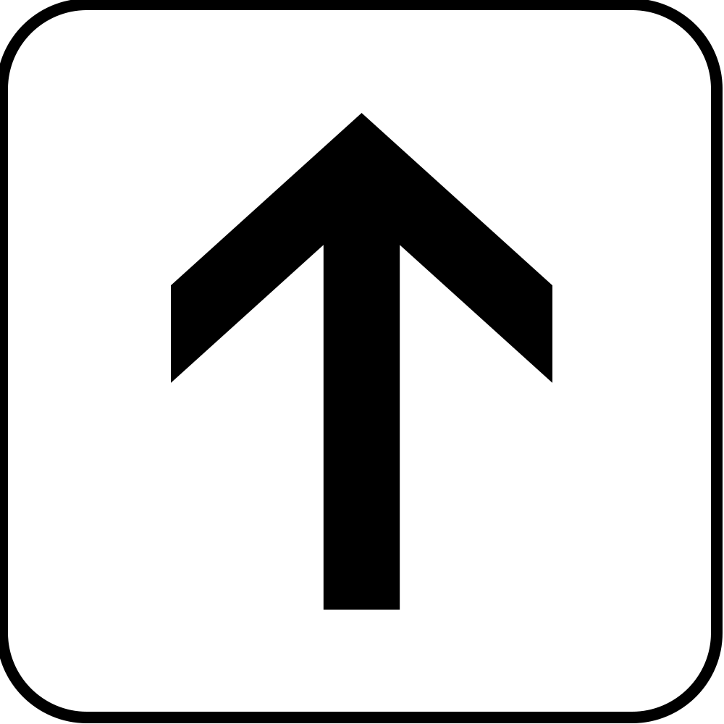 and Down arrow keys on your keyboard.
- You can also Shift-drag the playhead in the Timeline to snap to an edit point.

Useful Preference Setting
- From the top menu choose Premiere Pro > Preferences > Timeline (Mac) or Edit > Preferences > Timeline (Windows).
- Enable this setting:

- Now when you drag the Playhead in the Timeline it will automatically snap to edit points. No need to Shift-drag.

Insert and Overwrite Buttons
- These are located at the bottom of the Source Monitor, where you preview media.
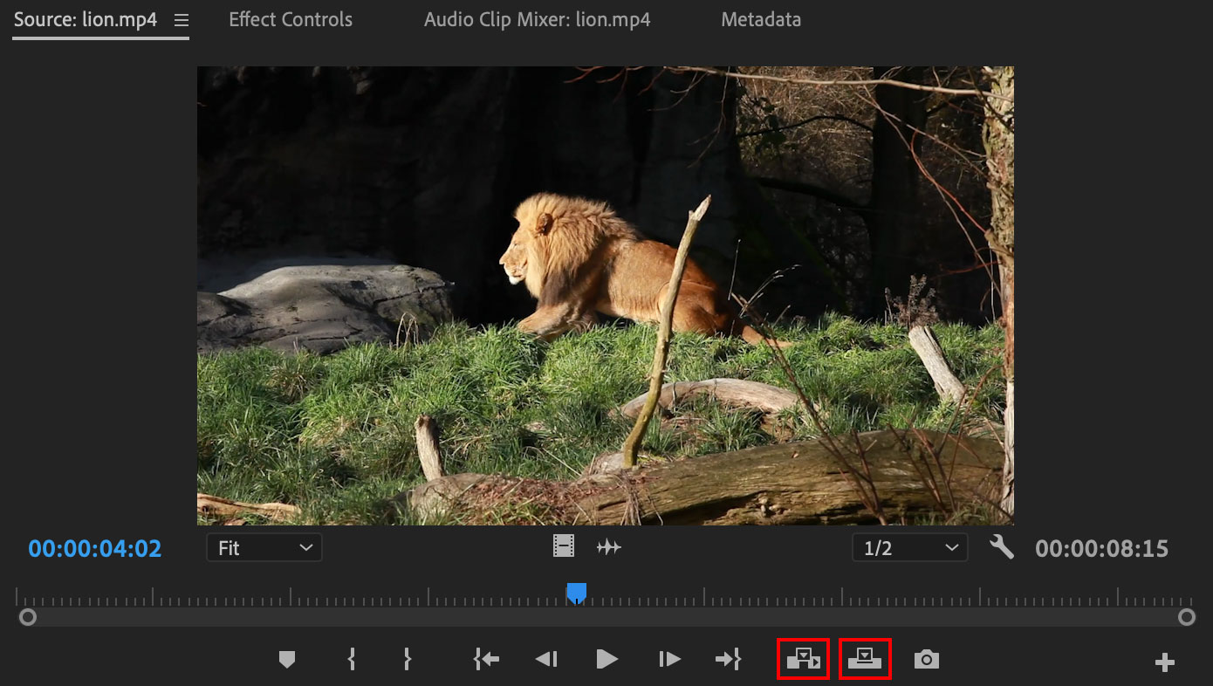

Overwrite Edit
- With this button, you will add the clip to the Timeline and overwrite any media in the Timeline.
- You can also simply drag media into the Timeline to perform an overwrite edit.

Insert Edit
- With this button, you will insert the clip into the Timeline. Normally you will want to be at an edit point.

Adding Music:
- Double-click a music clip in the Project Panel to open it. Mark In and Mark Out if necessary.
- Drag the music clip into the Timeline using the Drag Audio button. You can also drag directly from the Project Panel.
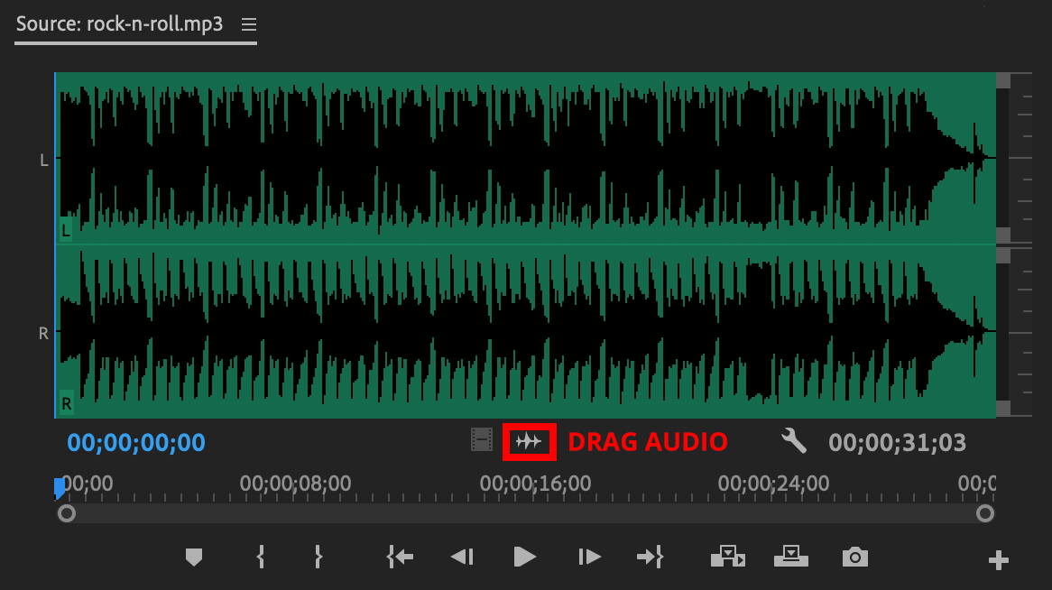
- Trim the music with the Razor tool if necessary.

Mute and Lock
- Mute a track by clicking the Mute button at the beginning of the track.
- Lock a track by clicking the Lock button at the beginning of the track. This is especially useful when performing insert edits that may split the track accidentally.
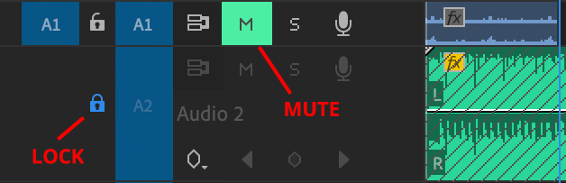

Resetting Workspace
- If you accidentally close a panel or the workspace on your screen gets messed up, you can do the following:
- From the top menu choose Window > Workspace > Editing, or the workspace of your choice.
- Then choose Window > Workspaces > Reset to Saved Layout and the workspace should come back to normal.

Patching Tracks
- On occasion you may drag a clip into the Timeline, but it doesn't get added properly. Either the audio, video or both are missing!
- If this happens make sure the correct tracks are patched. This is the first column of blue rectangles at the beginning of the Timeline:
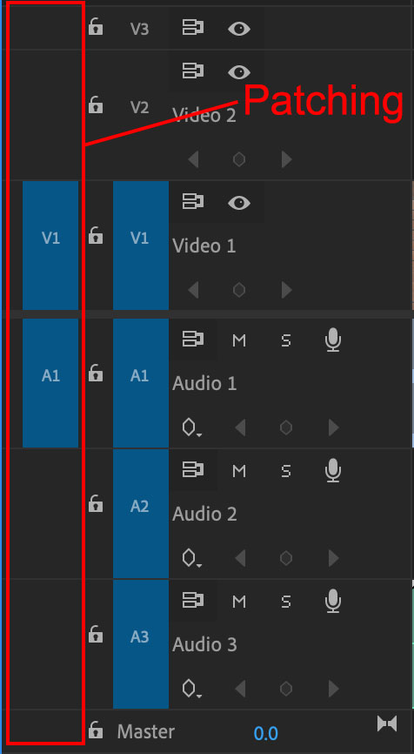
- In the example above V1 and A1 are patched (highlighted in blue) and everything should work normally.
- If for some reason no video track is patched, or no audio track is patched then clips may not get inserted into the Timeline properly.
- To patch or unpatch simply click inside the patching column with your mouse.
- Only one video track can be patched at a time, and one audio track.

