ADOBE PREMIERE PRO FOR COMPLETE BEGINNERS
by Navin Kulshreshtha, Lead Instructor at LearnPremiere.com

WEEK 1 SUMMARY

Download Media
- Welcome to the course! Be sure to download the course media from the course page, which is contained in a ZIP file. You can access the course page by going to LearnPremiere.com and clicking on My Account.
- Then unzip the file and place the contents in an easy-to-find location on your computer such as your Desktop.

STEP 1: Get Organized!

- Create a project folder and give it a descriptive name such as Zoo-Video or similar. In the example below the folder is called Skateboarding-Video.
- Inside the project folder, create several subfolders to keep the project organized. Here is an example:
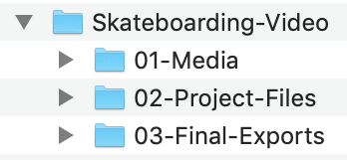
- Place all your media inside the 01-Media folder.
- Start Premiere Pro and create a new project file by choosing File > New > Project from the top menu.
- Click on the Browse button and navigate to the 02-Project-Files folder.
- Give the file name a descriptive name such as Zoo-Video-Edit or similar.
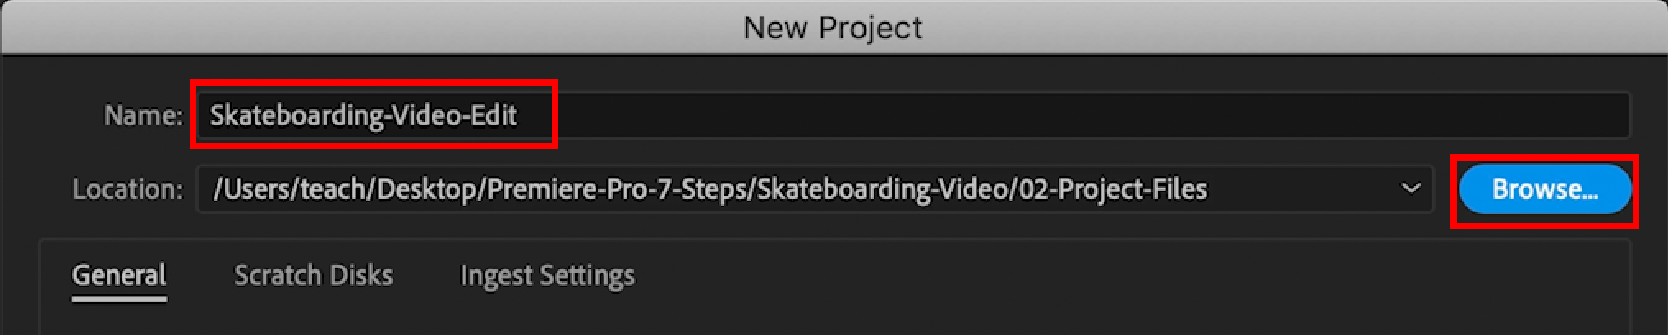

STEP 2: Import Media

- Choose File > Import > Media and browse to the 01-Media folder.
- Select all of the media files and import.
- To select a range of files, click on the first file then Shift-click on the last one.
- Each of the little windows inside Premiere Pro is called a Panel. And the arrangement of panels on the screen is called a Workspace.
- Change to the Editing workspace by choosing Window > Workspaces > Editing from the top menu.
- If necessary you can reset the workspace by choosing Window > Workspaces > Reset to Saved Layout.

STEP 3: Browse Media

- Your media will appear in the Project Panel.
- Move your mouse over the Project Panel and use the Accent/Tilde 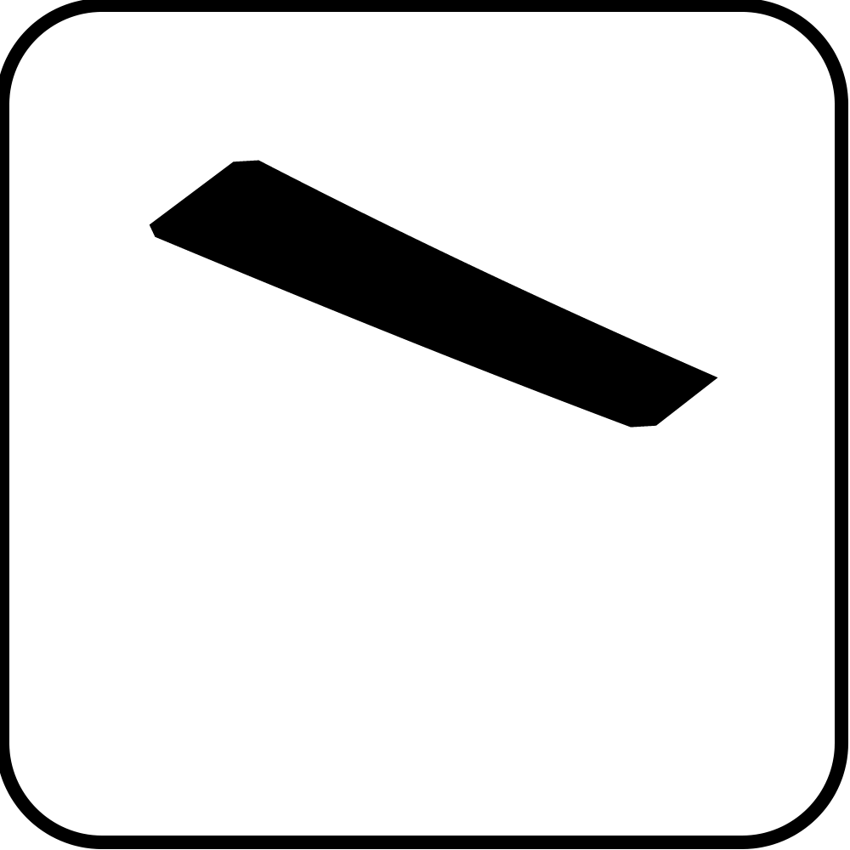 key to maximize the panel. This key is below the Esc key on many computers:
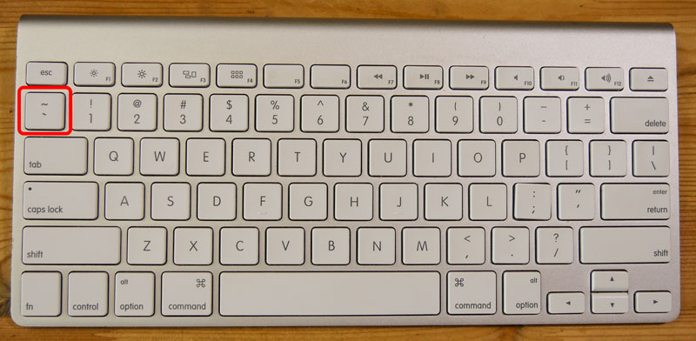
- Use the buttons at the bottom of the panel to switch between List View and Icon View.
- Drag the Zoom Slider to change the size of the icons.
- Use the Sort Icons button to change the sort order (only works in Icon view) and then choose Name to sort alphabetically by clip name.
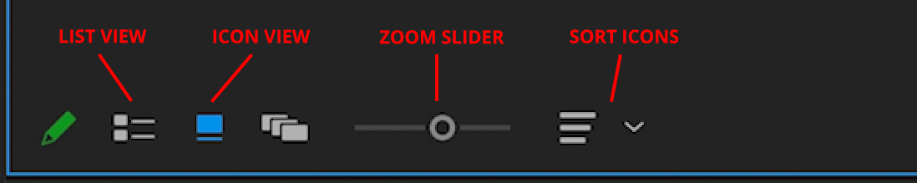
- Move your mouse (without clicking) from left to right over top of a clip to preview it. This is called Hover Scrub.
- Single-click a clip to select it. Hover Scrub will not work, but you can drag the rectangular playhead to preview it.
- Double-click a clip to open it in the Source Monitor.

STEP 4: Select Media

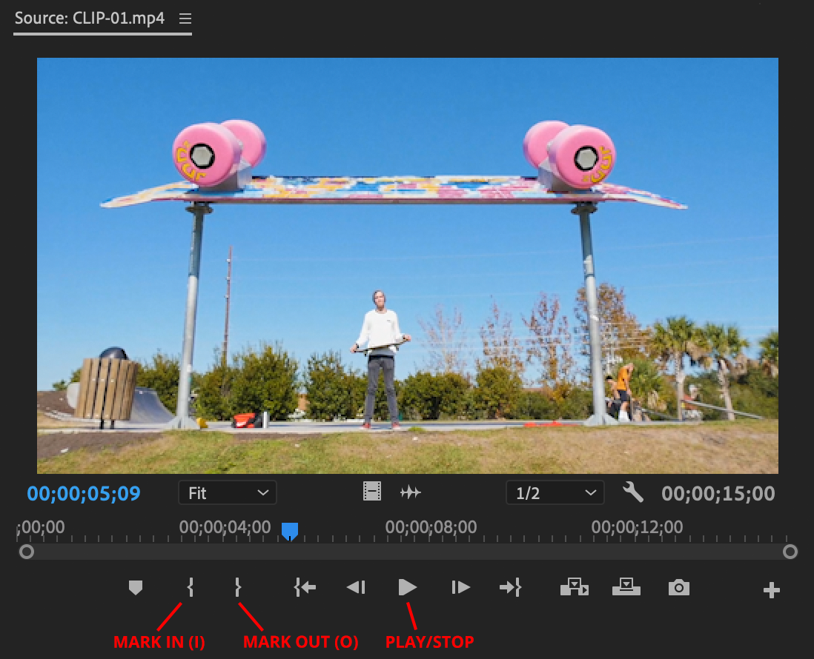

- Use the Up arrow key  on your keyboard to go to the beginning of the clip. The Home button will also work, if your keyboard has it.
- Use the Spacebar on your keyboard to play and stop the video. You can also use the Play/Stop button in the Source Monitor.
- Use the keyboard shortcut I or the Mark In button or to mark the beginning of your selection.
- Use keyboard shortcut O or the Mark Out button to mark the end of your selection.
- The times are in format hours:minutes:seconds:frames so 00:00:15:00 would be 15 seconds.

STEP 5: Timeline

- Add a clip to the Timeline by dragging and dropping it.
- Increase the track height by double-clicking the empty space in the track header. See screenshot below:
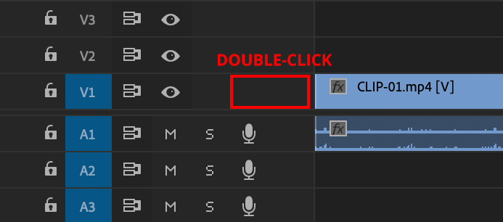
- The scroll bar at the bottom allows you to move and zoom in the Timeline.
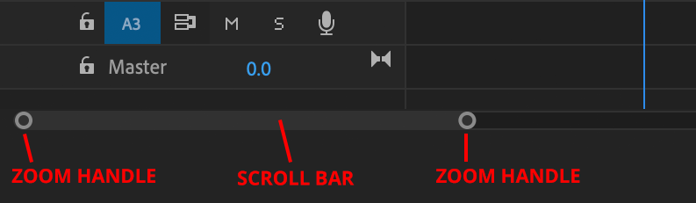

STEP 6: Refine the Edit

Trimming Clips:
- Be sure to have the Selection tool active in the Tools panel.
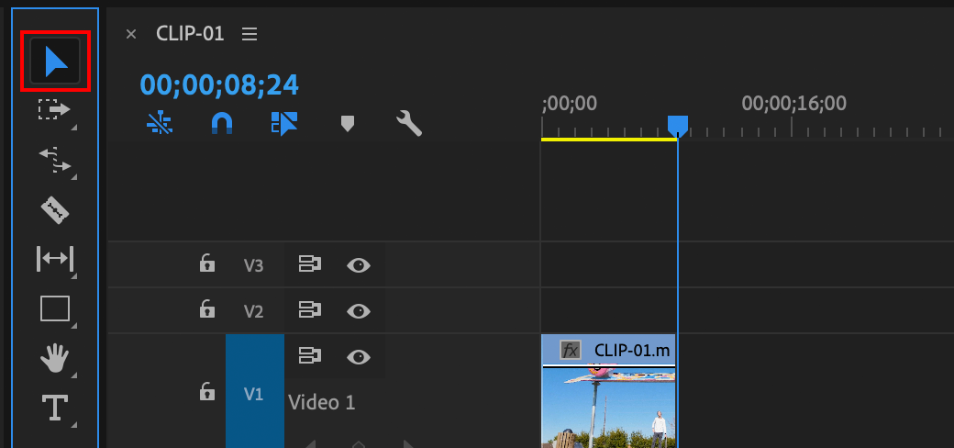
- Trim a clip in the Timeline by dragging the edges of it. Look for the red arrow when trimming.
- Remove a gap by right-clicking it and choosing Ripple Delete. If you don't have a right-click, Ctrl-click often works.
- To extend a clip you may have to move a neighboring clip out of the way by dragging it. Select multiple clips by selecting them with your mouse and then dragging them.

Using Razor Blade Tool to Trim
- Select the Razor tool from the Tools panel.
- Click directly on a clip to split it into two pieces.
- Select the Selection tool (black arrow) from the Tools panel.
- Click on any extra clips in the Timeline and hit Delete on your keyboard to remove it.

Moving Clips:
- Be careful when dragging clips in the Timeline as you may overwrite or delete existing clips.
- You can move clips by using Cut and Paste.
- Cut a clip using Edit > Cut, or Cmd-X (Mac) or Ctrl-X (Windows).
- Move through the Timeline one clip at a time by using the Up and Down arrow keys on your keyboard.
- Shift-drag the playhead to snap to an edit point, which is the exact point where two clips meet.
- Paste the clip by using Edit > Paste Insert. Be sure you are at an edit point.
- The fastest way to move a clip is to hold down Cmd on Mac or Ctrl on Windows (keep the button held down), then drag a clip to a new location, then release the Cmd or Ctrl button.

